VMware recognizes that today’s students are tomorrow’s trailblazers and value the opportunity to benefit from your fresh perspective. VMware is looking for talented Bachelor’s, Master’s or PhD students who have passed in last 12 months to fill NCG positions within Network and Security R&D organization.

VMware (NYSE: VMW),: VMware is the leader in virtualization and cloud infrastructure solutions that enable our more than 350,000 enterprise and SMB customers to thrive in the Cloud Era by simplifying, automating and transforming the way they build, deliver and consume Information Technologies. Our team of 11,000+ people working in 50+ locations worldwide is committed to building a community where great people want to work long term by living our values of passion, innovation, execution, teamwork, active learning and giving back. The Network and Security Business Unit has a strong R&D organisation in Pune, that is committed to virtualise the networking and security landscape in IT. If you are ready to accelerate, innovate and lead, join us as we challenge constraints and problem solve for tomorrow today.
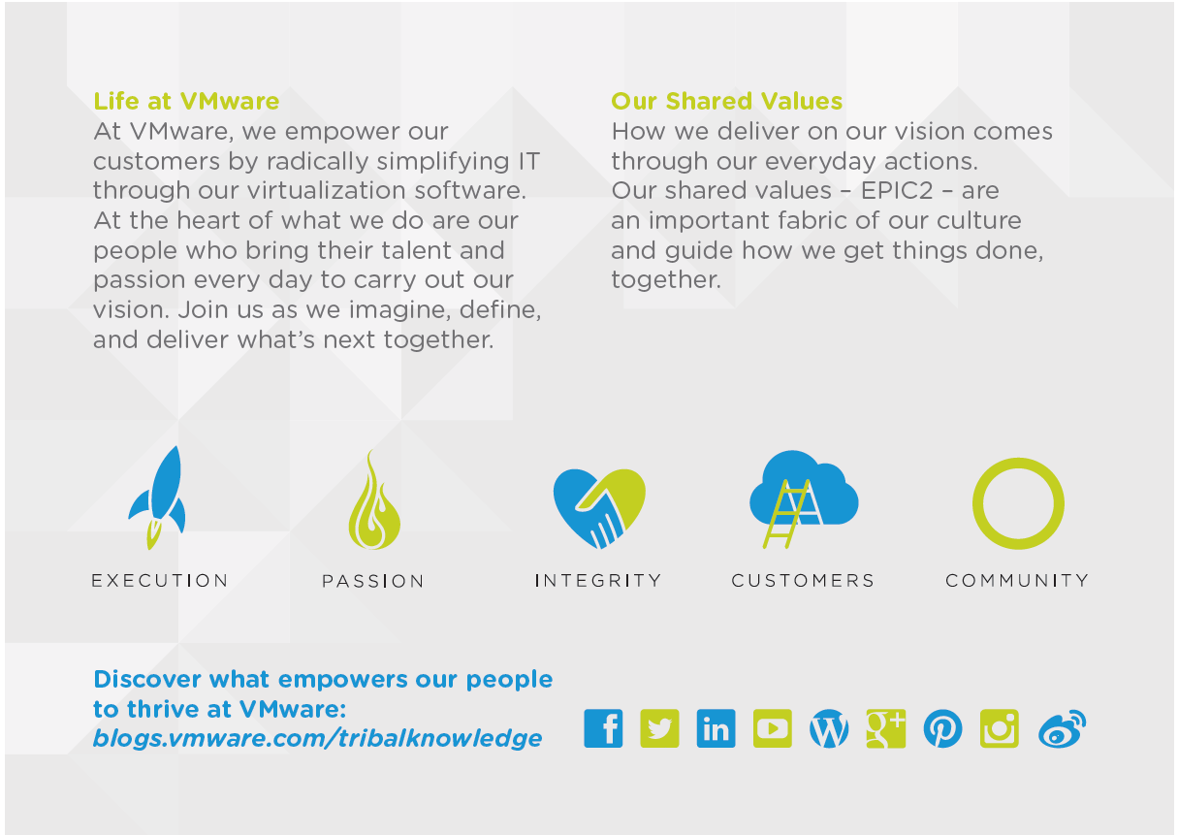

If you thrive in an open, innovative, technology-driven culture, then take a minute to learn more about VMware and apply today!
As a New College Graduate, you get exposure to huge range of software platform technologies that are loved by customers all over the world. So, what is your passion? Where do you see yourself working? Is it in Systems, Cloud Networking and Security, Distributed systems, Performance engineering, Front End Engineering, Backend engineering, Automation or Quality Engineering.
Requirements:
• Bachelors, Master’s Degree or PhD in Computer Science or equivalent with zero to one year of experience.
• Completed coursework in operating systems, computer architecture, networking, Distributed systems.
• Experience in one of the following: C, Java or C++.
• Experience with one of the following: Python, Perl, shell, or other scripting languages.
• Experience developing client-server or distributed, multithreaded applications.
• School or industry projects with high quality involving design and development.
• Passion to build a career in the domain of networking and security. Previous internship experience in similar domain is a plus.
• Willingness to learn new technologies, including commercial and open-source.
• Strong interpersonal, written and verbal communication skills.

Learn more at vmware.com/careers/ur Write to us at urinidia@vmware.com
Connect with university relations on:

