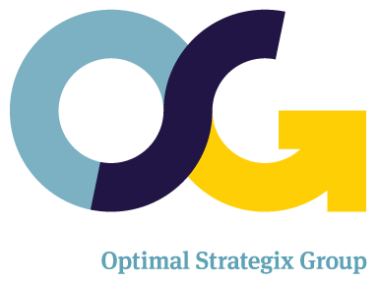
JOB DESCRIPTION
Position Information
Title: UI/UX Designer & Developer | Department: Analytics
Location: Bengaluru, India | Employment Type: Full-Time Position
Scope / Objective:

The position of UI/UX Designer & Developer reports into the AVP of Technology Solutions and provides a unique opportunity to contribute to the overall growth of the company. This position requires outstanding client service, dedication to company goals, and passion for quality.

Key Responsibilities

- Be a part of a development team to deliver new applications
- Focus on designing and developing a unified experience across OS platforms
- Collaborate with Product Managers and business teams to create friendly, elegant, intuitive experience for both consumers and enterprise users
- Deliver high-quality, scalable, and maintainable software; contribute technically to projects
- Develop and manage extensible, stable code bases for a variety of applications
- Provide design and front end development subject matter and thought leadership
- Collaborate with business users, internal and external technology teams in order to deliver a scalable application that exceeds requirements ensuring compliance with enterprise standards
- Evaluate various frameworks, technology and platforms to build custom applications
- Identify new opportunities, tools, and services to enhance the custom software platform
- Support and troubleshoot issues (process & system), identify root cause, and proactively implement sustainable corrective actions

Education / Experience / Skills Requirement

- Excellent written and verbal communication skills
- Bachelor's degree in Design (e.g. interaction, graphic, visual communications, product, industrial), Computer Science, Human Computer Interaction, (or equivalent relevant work experience)
- 3+ years of experience with web technologies and frameworks (HTML5, CSS, Sass, Ajax, JavaScript, jQuery, EXT-JS)
- 2+ years of experience with iOS, Android, Xcode SDK, Objective C, Java; developed mobile working applications
- Experience with mobile optimized responsive design
- Strong knowledge of design principles, issues, and techniques
- Write functional code to abstract the front-end
- Strong understanding of RESTful API design
- Ability to prototype in vector tool of choice (Illustrator, Sketch, etc.)
- Proven ability to complete rapid prototyping, and deliver/support production-quality code.
- Experience with data integration, relational databases, and business applications
- Working in an Agile environment; knowledge of SCRUM framework a plus
- Strong team-building, vendor and customer relations skills

